IKEA Italic Print Sofa

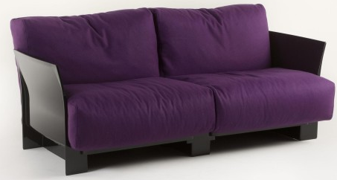

|  |
| --- |
| **DESCRIPTION** |
| The sofa designed by IKEA manufacturer is build in a complete new design which is rested upon soft air tight cloth cushion and long supported round frames barricades the sofa cushion from falling out in order to main the shape. Its design gives a glowing and soothing look which is preferred by most people. The support of the sofa from middle prevents the sofa from bending and breaking the thick wood even though high pressure is applied. |

|  |  |  |
| --- | --- | --- |
| **Price** | **2755$** | |
| **Dimensions** | **H** x **W** x **L** | **36in x 33in x 69in** |
| **Features** | **The sofa is build for two but four people can also sit at once. The purple color gives a great look on the sofa.** | |
| **Finished** | **Smooth Bulky Cloth** | |
| **Available in** | **Purple and Green** | |